Chapter 5, Problem 32

Calculate i_{x} and v_{o} in the circuit of Fig. 5.70. Find the power dissipated by the 60-kΩ resistor.
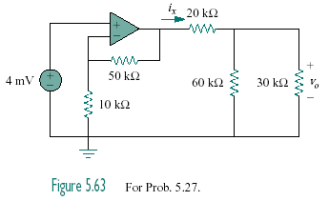

Figure 5.70
For Prob. 5.32.

